Hamed Khashehchi 9723494

Candidate elimination

we use the algorithm that mentioned in mitchells book:

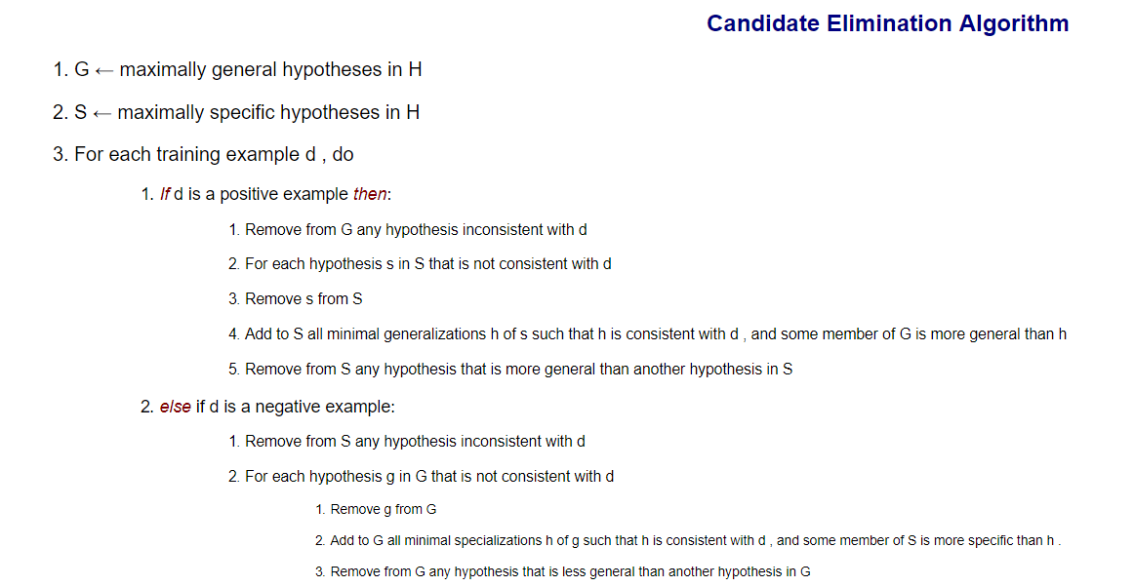

CandidateElimination : most important of all of them, major portion of the code is present in form of various concepts like positiveEncounter, negativeEncounter , finding minmal specification set and generalization too.

Hypothesis : describes about the hypothesis structure and data regarding the attributes used and functions like is Consistent and isMoreGeneralThan is present etc

minimalSpecialization : given hypothesis, training example it deduces all the minimal specification of hypothesis which are consistent with training example.

minimalGeneralization : given hypothesis, training example it deduces all the minimal generalizations of hypothesis which are consistent with training example.

moreGeneralThan: determines whether a given hypothesis is general than other hypothesis.

consistent: tells us whether a hypothesis is consistent with training example.

getVersionSpace: it uses general and specific boundaries to generate version space.

Delay on submission:

I had to delete my first answer cause I had no docs I forgot it:P